CS6360.MS1 Spring 2021

Assignment 2 – Install a Database

There are three parts to this assignment.

1. Install a relational database manager on your computer. Unfortunately, you can’t use the lab computers for this. As I have said in class, you can work with MySQL, MariaDB or Microsoft SQL Server. Make sure you install the tools, such as the MySQL Workbench or SQL Server Management Studio. You can get an “express edition” of the Microsoft product free, which is what I have installed and will be using in class. However, any of the three is fine for this assignments and ones that follow.
2. Download the Company database text file (with a .sql extension) from eLearning. If you got the one from my Web site, that won’t work. Run the script to create the database. Take a screen shot of your screen showing connectivity to the Company database, including the list of tables. This will be handed in. (20 points.)

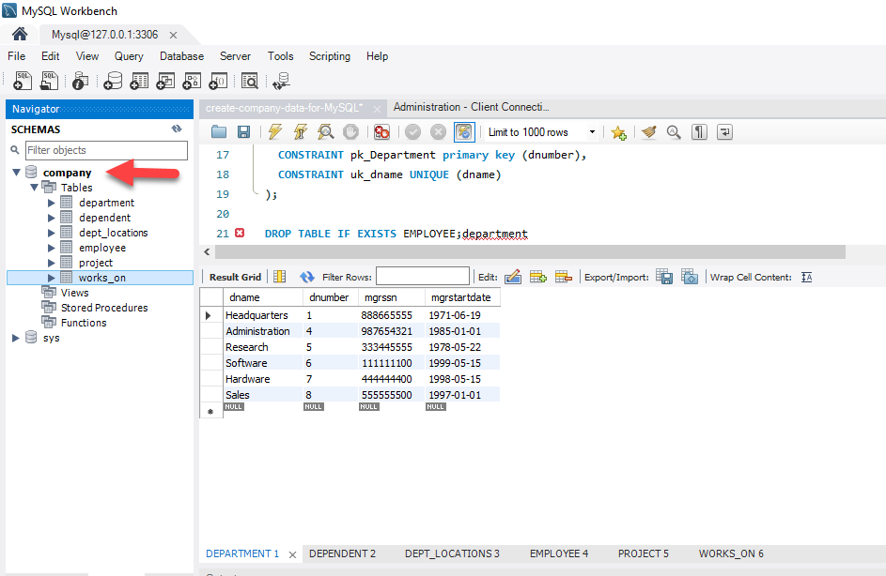

1. Run the following queries and take screen captures of the query and showing the results. Your screen shots must show the query text along with the results. (5 points each):
   1. Insert your name into the Company database employee table with social security number of 111111111 and department 6. You don’t need to use your real address.

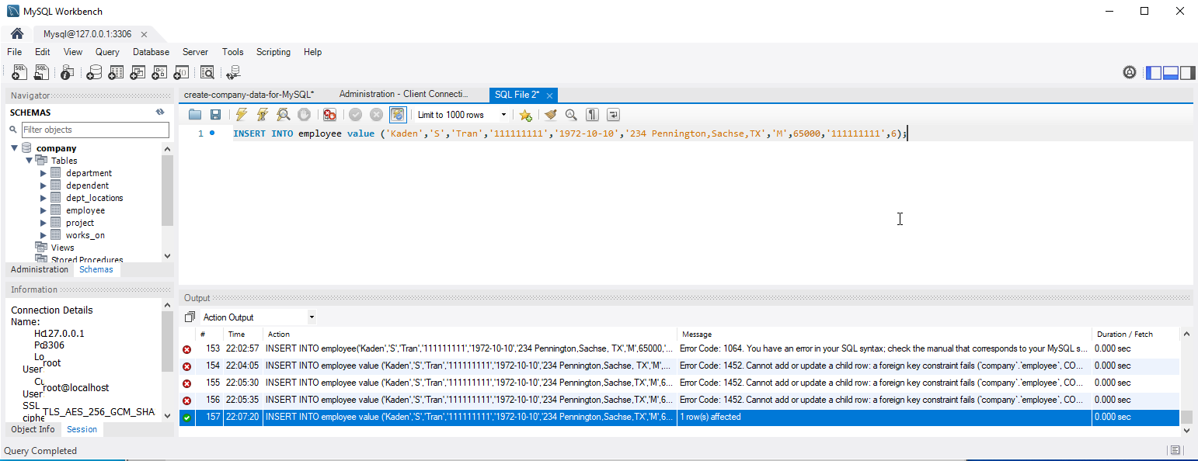

Query: INSERT INTO employee value ('Kaden','S','Tran','111111111','1972-10-10','234 Pennington,Sachse,TX','M',65000,'111111111',6);

* 1. Update your employee record to show 111111100 as your supervisor. Query to show your record only.

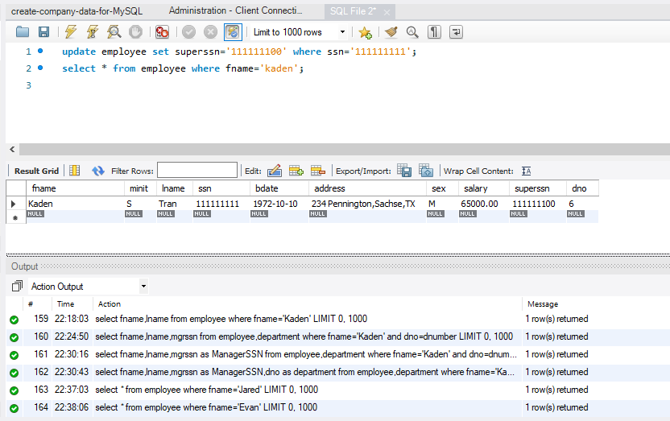

Query:

update employee set superssn='111111100' where ssn='111111111';

select \* from employee where fname='kaden';

* 1. Show all employees who work for supervisor Jared D. James and those who work for supervisor Evan E. Wallis. That is, everyone who works for either one of those two people. (You can write this so the query doesn’t involve the name, if you wish.)

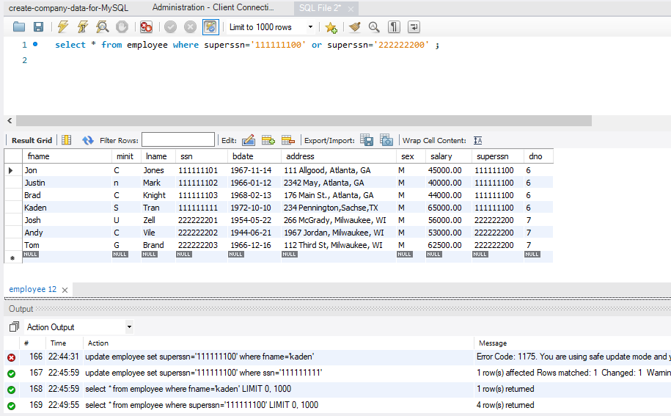

Query: select \* from employee where superssn='111111100' or superssn='222222200' ;

* 1. Show all employees who make more than $50,000 per year, who are over 30 years old, and who live in Wisconsin (state abbreviation WI.)

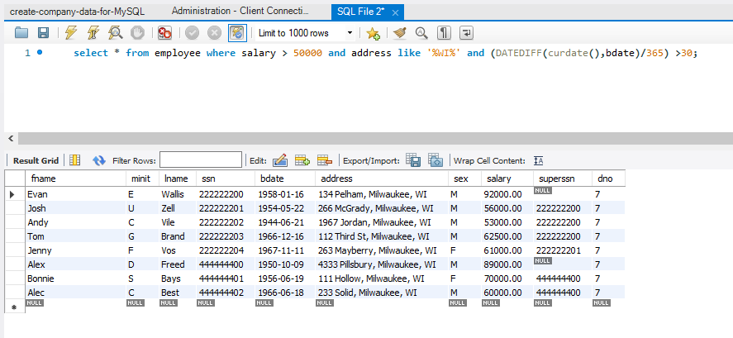

Query: select \* from employee where salary > 50000 and address like '%WI%' and (DATEDIFF(curdate(),bdate)/365) >30;

To hand in: A PDF or Word document containing the screen shots as describe in parts 2 and 3.